**Speech distance alarm**

## 1. Purpose

In this lesson, we will learn how to use micro:bit to drive the speech synthesis module and ultrasonic module to realize the speech distance alarm function.

**2. Preparation**

The I2C communication used by speech synthesis module module.

|  |  |
| --- | --- |
| Speech synthesis module | Arduino UNO board |
| SCL | SDA |
| SDA | SCL |
| VCC | 5V |
| GND | GND |

|  |  |
| --- | --- |
| Ultrasonic module | Arduino UNO board |
| TRIG | 7 |
| ECHO | 8 |
| VCC | 5V |
| GND | GND |

****3. S**peech synthesis **module protocol****

The speech synthesis module is configured and used in accordance with the specified data frame through the I2C communication.

More details, please check [1.Introduction]--[1.2Communication protocol].

1. **About code**

Please check .ino file.

**5. Compiling and downloading code**

We need to open the .ino file by Arduino IDE software. Then, click“√”under the menu bar to compile the code, and wait for the word "Done compiling " in the lower left corner, as shown in the figure below.

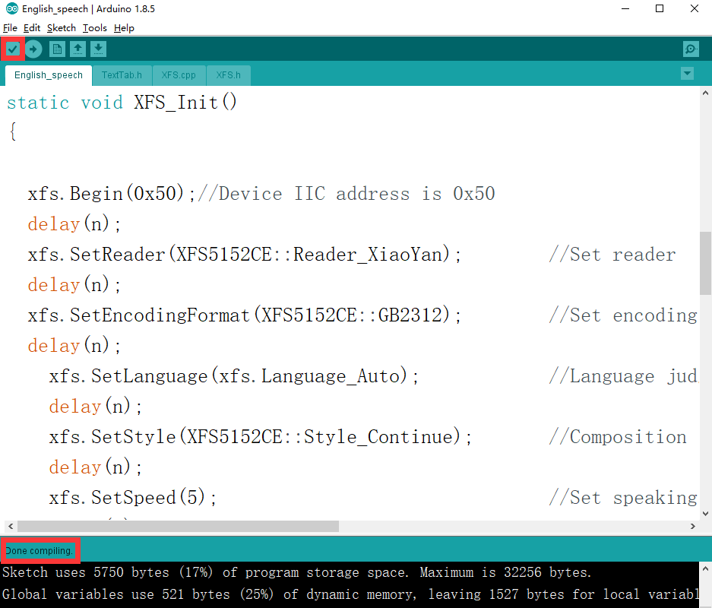5.2 In the menu bar of Arduino IDE, we need to select 【Tools】---【Port】--- selecting the port that the serial number displayed by the device manager just now, as shown in the figure below.

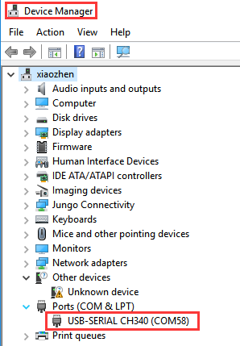

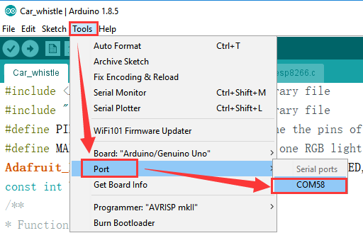

5.3 After the selection is completed, you need to click “→”under the menu bar to upload the code to the UNO board. When the word “Done uploading” appears in the lower left corner, the code has been successfully uploaded to the UNO board, as shown in the figure below.

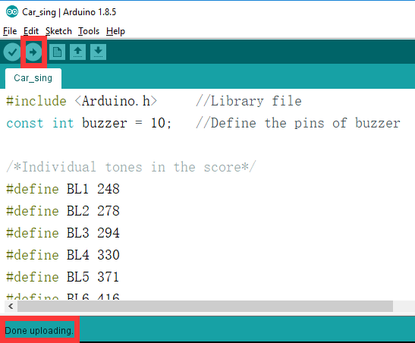

**6. **Experimental phenomena****

After the program is downloaded successfully, micro:bit will display a smile face.

When there is an obstacle within 30 cm in front of the ultrasonic module, the voice module will play "There is an obstacle in front", and it will play distance.

**6. 实验现象**

程序下载成功以后，当超声波检测到前后距离小于30厘米，则会播报“前方有障碍请注意避让，距离为xx厘米”。